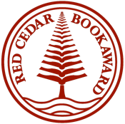 |  | RED CEDAR BOOK AWARD - 2021/2022  OFFICIAL Nominated Books – FICTION
Title |  |  | Author | Publisher
 | BARREN GROUNDS |  | David Robertson | Penguin Random House
 | HEAD TO HEAD |  | Jennifer Manuel | Lorimer Press
 | KING OF JAM SANDWICHES |  | Eric Walters | Orca
 | LOST SCROLL OF THE PHYSICIAN |  | Alisha Sevigny | Dundurn
 | ME AND BANKSY |  | Tanya Lloyd Kyi | Penguin Random House
 | MY NAME IS KONISOLA |  | Alisa Siegel | Second Story Press
 | RED FOX ROAD |  | Frances Greenslade | Penguin Random House
 | RIDE HOME |  | Gail Anderson-Dargatz | Orca
 | ROYAL GUIDE TO MONSTER SLAYING: GRYPHON'S LAIR |  | Kelley Armstrong | Penguin Random House
 | YARA'S SPRING |  | Jamal Saeed and Sharon E. McKay | Annick Press

